A Review of Virtual Reality (VR)

2016 09

**ABSTRACT**

Nowadays, users from common people to Professionals; devices from cheap google cardboard (Mobile) to relative more functional and costly Oculus Rift (PC); applications from videos games to The European Cup live broadcast…, VR almost been talked everywhere. By artificially stimulating our senses, make it possible for our bodies become tricked into accepting another version of reality. [In](javascript:void(0);) [the](javascript:void(0);) [field](javascript:void(0);) [of](javascript:void(0);) [game](javascript:void(0);), VR bring people from the outside to the inside of the games. In this paper, we introduced the definition, the history, limits, and development trend of VR technology.

**INTRODUCTION**

Ⅰ. What’s Virtual Reality (VR)

“Virtual reality” - VR for short, is commonly used by the popular media to describe imaginary worlds that only exist in computers and people’s minds. Also be defined as “it is a computer technology that replicates an environment, real or imagined, and simulates a user's physical presence and environment to allow for user interaction. Virtual realities artificially create sensory experience, which can include sight, touch, hearing, and smell.” by **Joseph Isaac** in 2016[1]. In the book <the VR book> virtual reality is defined as “it is a computer-generated digital environment that can be experienced and interacted with as if that environment were real”, and asserted that VR is Communication, the author of this book emphasized the importance of human factor that influence the interaction between the VR system and the users[2]. In a nutshell, VR is using computer or other devices simulate and generate a virtual world that be available to users interact with, and get immersive experience. It’s an art form that plays with that interaction it’s all about reality and people. There are 3 main Characteristics VR have: immersion; real-time interactivity, imagination.

Ⅱ. The Development (history) (background) of VR

**2.1 History**

VR already has 80 years history. In 1928, **Edwin Link** developed the first simple mechanical flight simulator, a fuselage-like device with a cockpit and controls that produced the motions and sensations of flying, this is the First Experience of Simulator. By 1935, Link trainers eventually evolved into astronaut training systems and advanced flight simulators complete with motion platform and real-time computer-generated imagery, Since Virtual reality can be used to make the simulation scenes more immersive, it is expectative to use in the domain of education and professional training.

The development history of VR can be approximately divided into 3 periods, **20 century 30s~70s - the exploration stage**, In 1935 American science fiction writer [Stanley G.Weinbaum](http://en.wikipedia.org/wiki/Stanley_G._Weinbaum) the very first time presented a concept of a comprehensive and specific fictional model for virtual reality in his short story [4]. Sutherland I.E. the creator of one of the world’s first VR systems, he made an assumptions that generate a Virtual world that enable users directly interact and immerse with instead of view the Virtual scene though screen and Dr. Frederick P. Brooks, Jr., inspired by Ivan Sutherland’s vision of the Ultimate Display [3], established a new research program in interactive graphics at the University of North Carolina at Chapel Hill, with the initial focus being on molecular graphics and in 1967, developed the first VR device HMD (head mounted display) and he stated:” The screen is a window through which one sees a virtual world. The challenge is to make that world look real, act real, sound real, feel real.” **During 80s - VR technology systematize from laboratory to practical stage**. In 1985, Scott Fisher, now at NASA Ames, along with other NASA researchers developed the first commercially viable, stereoscopic head-tracked HMD with a wide field of view, called the Virtual Visual Environment Display (VIVED). **From 90s to now - the high speed development stage**. VR exploded in this period with various companies (Sega, Disney, and General Motors, as well as numerous universities and the military etc.) focusing mostly on the market and entertainment (movies, books, and is also active in journals, conferences), in 2000s, there are plenty of Original stage products be published, however because of the limits of VR technology it is not popularize so yet, in the years to come, the more forming and good price VR products will be Flow to the market and be the become mainstream.

**2.2** **Development Status and Limits (Disadvantages):**

VR is getting out of the lab and stepping into common people’s daily life, there are plenty of devices be produced, but the VR market hasn’t yet reach a consumer Grade, Among the reasons for VR not popularize is relatively good products cost a lot, however, the cheaper ones can’t provide a good experience the user expected. The VR devices must rise to the challenges such as [High-speed](javascript:void(0);) [image](javascript:void(0);) [processing](javascript:void(0);); new way for [geometric](javascript:void(0);) [and](javascript:void(0);) [physical](javascript:void(0);) [modeling](javascript:void(0);) ; [Artificial](javascript:void(0);) [intelligence](javascript:void(0);) , [psychology](javascript:void(0);) , [sociology](javascript:void(0);) problems to solve. It has been applied in many domains, but can’t exactly provide our mind with direct access to digital media in a way that seemingly has no limits, here is the VR products’ representative limits:

Hardware:

* Screen
  + Resolution: if the resolution is too low, visually watch grainy strong, theoretically resolutions need higher than 4K.
  + Refresh frame rate: Frame rate is too low, the picture is likely to cause delay, need to reach at least 120HZ.
  + Viewing angle: if visual range is bigger than the screen, it’s easy to affect the viewing experience and immersion through eye movement.
* Weight/ battery life: heavy equipment, after long periods of oppression can make user discomfort and add fatigue, short battery life is not enjoyable.
* Interaction:
  + Some unnatural ways: touch the screen; magnet button; Joypad adaptor; Single Bluetooth. It is important to find a more fitness way that people can easy interact with as much as possible like the real world.
  + Vertigo: ubiquitous like Motion sickness, easy to cause discomfort to the user, devices cannot be long term use.

Ⅲ. VR applications and Forms of VR devices

**3.1 VR applications in education**

As VR technology has enormous potentiality, but what is it made for? As Confucius stated: ”I see and I forgot. I hear and I remember. I do and I understand.(吾听吾忘，吾见吾记，吾做吾悟 – 孔子)” we can hear with our ears; see with our eyes; but can’t do whatever we want, VR make it possible for us to understand the world we live in more simple and direct. It is applied in games, film and television, Art Performance, live show, education, tourism, medicine and even social contact, etc. The most remarkable characteristic of VR is the fidelity, immersive and Real-time interaction, therefore VR education is an effective way for practical and creative education, as the teaching method can be very flexible. Students can have a strong sense of presence being in and control the virtual world made though software, during interaction with the objects with the help of human Instinct capacity of cognitive and perceptual, through more intuitive way course, facilitate the students better memory and understanding the knowledge.

In terms of school education, Professional skills training and scientific research, VR be used in [molecular](javascript:void(0);) [structure](javascript:void(0);) modeling, seismic exploration data processing, provide an intuitive visual graph, the natural sciences, humanities history, language, and physical, chemical fields etc. More essential can be the use in video games for the purpose of education. People can learn what they want though games, which is a pleasant and high efficiency way, VR can provide an immersive environment for students to experiences, obtain knowledge more effectively easier to remember though video games, meanwhile, VR can save the cost of study.

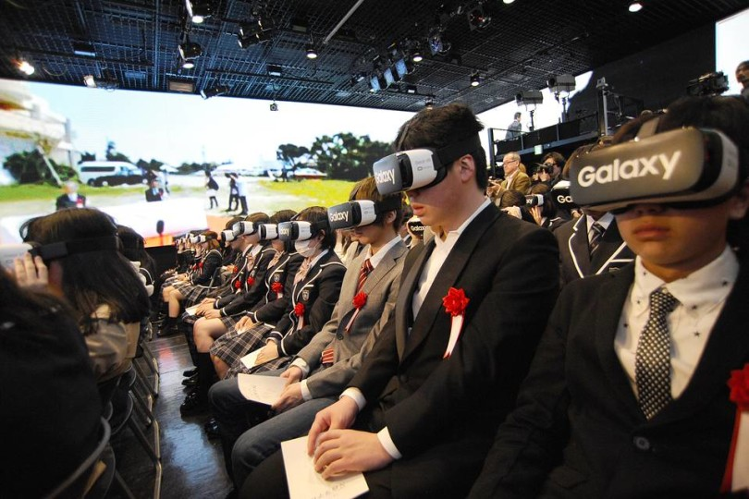

Fig.2. In Japan, Students Attend First Day of School in VR

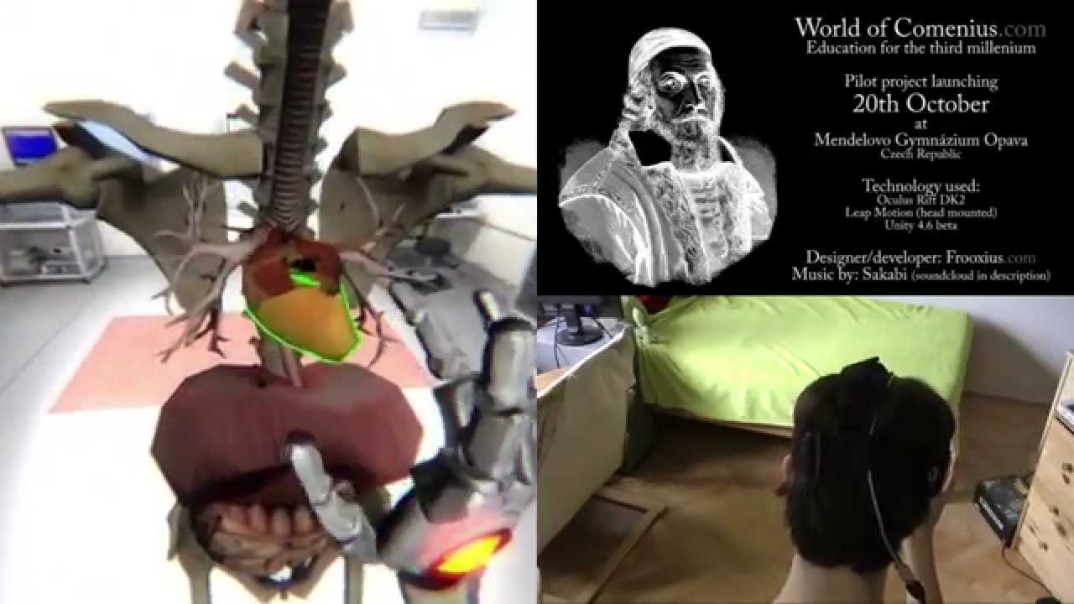

Fig.3. [**World of Comenius**](https://www.youtube.com/watch?v=-W18BylZk6o) - A biology lesson at a school in the Czech Republic that employed a Leap Motion controller and specially adapted Oculus Rift DK2 headsets, stands as an exemplary model of innovative scientific learning

VR also significant useful in fields such as medical treatment, military, aerospace, business, product design and manufacturing. E.g.: The Amazing Future of VR Medicine.

**3.2 VR devices**

The Composition of the VR devices can be classified as display device; input/feedback(interaction) device; and the filming equipment.

Display devices can also be divided into 3 kinds; PC+VR; Mobile +VR; and VR all in one. The pictures below are some well-known devices:

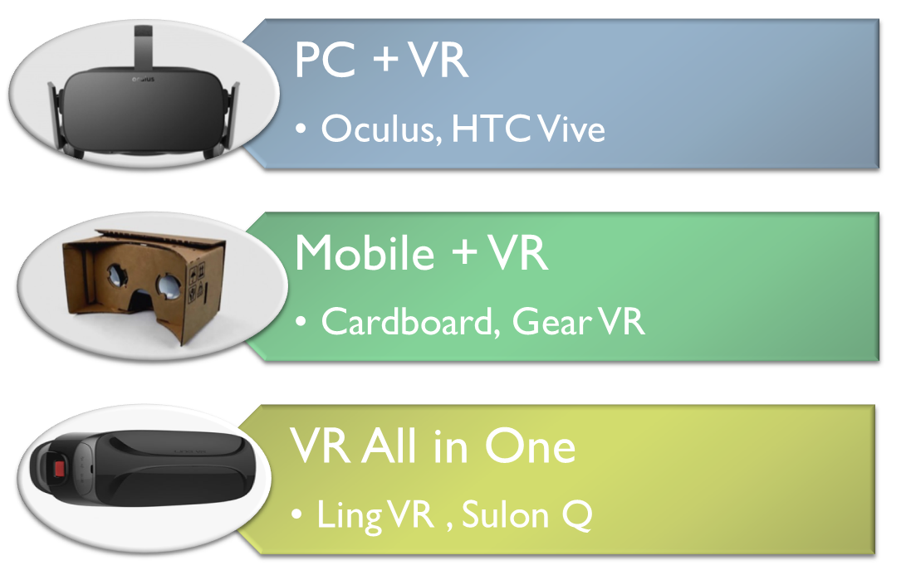

Fig.1. VR devices

Ⅳ. The development trend of VR

VR is getting closer and closer to the reality, as the representative of VR-PC helmet developers Sony PlayStation VR, Oculus Rift, HTC Vive Published [Consumer](javascript:void(0);) [products](javascript:void(0);) successively this year, lead users to better experiences. VR-Mobile also had a great revolution, Google DaydreamVR has been published at 2016 May Google I/O Conference, it optimized the Algorithm therefore it can [reduce](javascript:void(0);) [latency](javascript:void(0);) and vertiginous sensation effectively, it support various smart phones. The developers also further enriched software in watching movies, playing games, watching games.

While VR was a non-starter back in the 90s, developers are now creating mind-blowing experiences that look set to revolutionize gaming and entertainment. Today, virtual reality (VR) technology has been able to truly experience for consumers, but to rise to the level of industry, VR is still in the formative years, in terms of technology, products, content, specifications, are slightly immature.

With the development of VR technology application in education, entertainment, medical treatment, military, aerospace, business and product it is becoming more and more attractive. It is changing the way people perceive themselves, concepts of time and space, and the world, in the future, it will be more popularize, people directly experience it instead of just heard it or image it according to reports. 21 century will be the VR century. At that time VR can protect the children’s imagination, VR can make your dream came true.

**References**

[1] Joseph Isaac (2016). ["What is Virtual Reality?"](https://www.completegate.com/2016070154/blog/virtual-reality-explained#vrdef) completegate.com. Retrieved2 July 2016.

[2] Jason Jerald, NextGen Interactions (2016).” The VR Book: Human-Centered Design for Virtual Reality”

[3] Sutherland, I. E. (1965). The ultimate display. In The Congress of the International Federation  
of Information Processing (IFIP) (pp. 506–508). DOI: 10.1109/MC.2005.274. 9, 23, 30

[4] [Stanley G.Weinbaum](http://en.wikipedia.org/wiki/Stanley_G._Weinbaum)(1935)  [Pygmalion's Spectacles](http://www.gutenberg.org/files/22893/22893-h/22893-h.htm) http://www.historyofinformation.com/expanded.php?id=4543